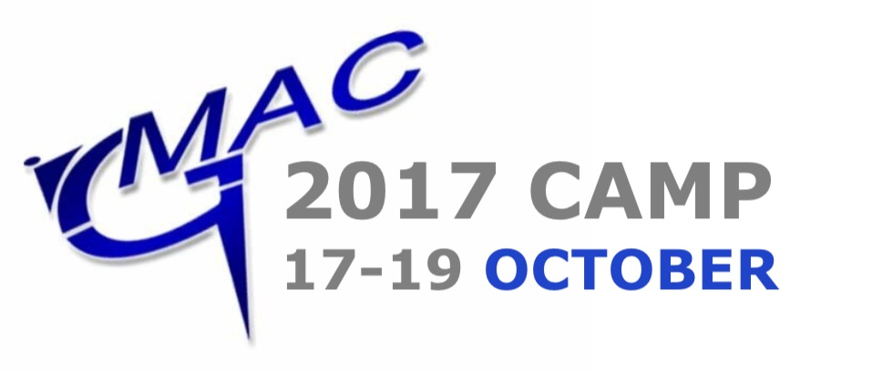

3 Days of Action-Packed Fun!!

9:00am – 3:00pm
Open to all students aged 5 & over.

A great way to keep the kids entertained this school holiday!
Activities include:

- Martial Arts Skills
- Fitness & Fun
- Pad Drills
- Team Challenges
- Games
- Board Breaking
- Flying Kicks
- Archery
- And more…

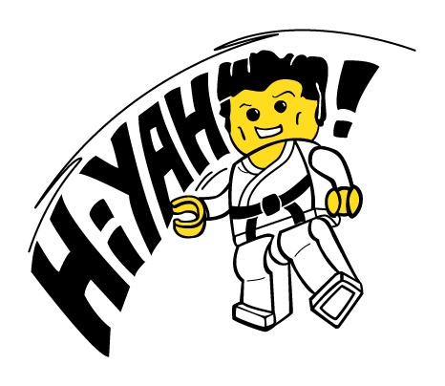
Healthy snacks & water provided. Just bring a packed lunch along each day.

You’ll also receive a special camp t-shirt!

Book by 10th October to ensure your spot.
Places are limited, and will be on a first come basis.

Book for 1 day, or all 3!

Cost per day £25.00
Three Days £60.00

Venue: GMAC Martial Arts, Craigshill Road, Livingston, EH54 5DT

www.gmacmartialarts.co.uk
CAMP APPLICATION FORM

CHILD’S DETAILS

NAME: _____________________________________ AGE: ___________________

ADDRESS: _________________________________________________________________________

____________________________________ POSTCODE: ___________________

GMAC GYM: ____________________________________ CLASS: ___________________

ALLERGIES: _________________________________________________________________________

MEDICATION _________________________________________________________________________

EMERGENCY CONACT DETAILS

- NAME: ______________________________ NUMBER: __________________
- NAME: ______________________________ NUMBER: __________________
- NAME: ______________________________ NUMBER: __________________

T-SHIRT SIZE

- 5 – 6 years
- 7 – 8 years
- 9 – 11 years
- 12 – 13 years
- Small adult
- Other: _________

ENROLEMENT

I wish to enrol my child on the following day(s) camp (please tick):

- Tuesday 17th
- Wednesday 18th
- Thursday 19th
- Tue, Wed & Thurs

I enclose the appropriate fee of £________.

Parent/Guardian Name: __________________________________________

Signature: __________________________________________

Date: __________________________________________

- Closing date for applications is 10th October. Places allocated on a first come, first served basis.

