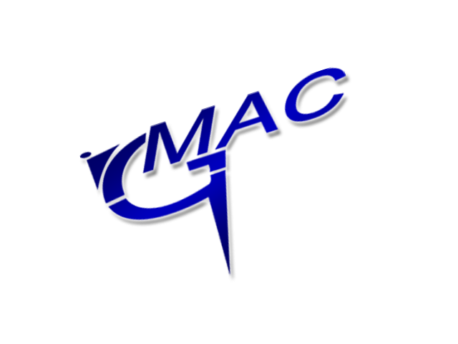
TKD Seminar with
Master Jedut
8th Degree

This August GMAC Taekwon-Do are honoured to host a seminar with World renowned Instructor Master Jerzy Jedut VIII from Poland.
Master Jedut is AETF Secretary General, Ex-National Coach to Polish Taekwon-Do Team, Instructor to a number of European & World Champions; including six-times World Champion and twenty-times European Champion: Mr. Jarosław Suska VI Degree, an iconic National Team Representative of Poland.
Master Jerzy Jedut will be in Scotland for one day only this August conducting seminars which will illustrate his passion for Taekwon-Do through a series of unique strength exercise’s, challenging kicking combinations and interesting methods on how to incorporate effectiveness of technique, control and optimum power from beginning to end in sparring & Taekwon-Do training.

This event will be held on Sunday 22nd September 2013. The seminar will be split into three sessions over the day:

Session Number | Time | Open to the following ranks and ages | Price
1 | 10.00 – 11.30 | Ages 12 and under  White Belt to Black Belt | £15
2 | 12.00 – 16.00 | Ages 13 and over  White Belt to Black Belt | £30

This seminar will be held in GMAC Martial Arts Centre, Livingston.

If you would like to participate in what promises to be a fantastic event, then please complete the attached form, and return it with the payment by Tuesday 2nd August 2016.

Note that the number of places for each session will be limited. Book early to avoid disappointment.

DON’T MISS OUT ON THIS FANTASTIC OPPORTUNITY!

GMAC Martial Arts

-----------------------------------------------------------------------------------------------------------------------------------
Application Form

NAME: _________________________________________ SCHOOL: _________________________________

AGE: ________ GRADE: __________________ SEMINAR NO: ________ FEE ENCLOSED: ____________

SIGNATURE (parent if under 16): ____________________________________ DATE: _________________

PLEASE NOTE YOU CAN ALSO BOOK DIRECTLY ONLINE @ http://www.gmacmartialarts.org.uk/news/seminar-with-master-jedut-8th-degree-7th-august/

