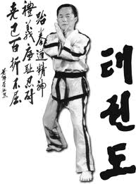
Taekwon-Do UK
Are pleased to invite you to our

3rd Scottish Open Championships
Kelvin Hall,International Sports Arena
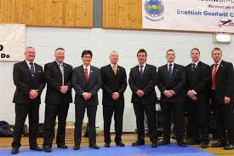
Glasgow, G3 8AW
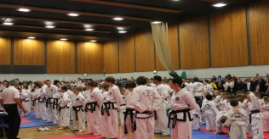
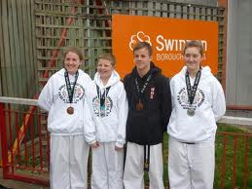
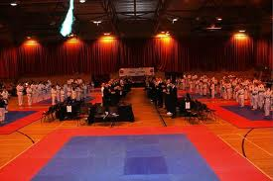
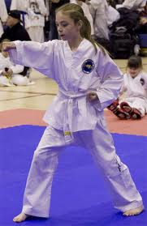
Open to Coloured and black belts
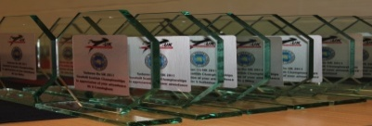
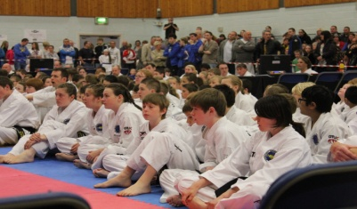
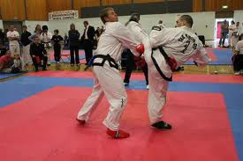
Saturday 18th May 2013
For information pack visit website or call
01555 751721/ 07825333432
www.tkd-uk.com

Dear Masters/Instructors /Students
On behalf of the Taekwon-Do UK executive, it gives me great pleasure to invite you to attend our Scottish Goodwill Open Championships. This Taekwon-Do event is open to coloured belt and Black belt competitors and is designed to unite TKD schools through our Martial Art of Taekwon-Do. These championships are a continuation of our successful International event held at Edinburgh three years ago with a big emphasis on fair play and light contact for competitors especially junior divisions to encourage scoring points rather than causing injury to your respected opponent.
Please note that as this is a goodwill event and we want each division to be as fair as possible, all junior categories will be designed on age, weight and height to keep physical and mental development as even as possible so please fill out entry forms correctly. Weigh in will commence prior to the sparring division starting.
I very much look forward to your attendance and promise as always I will help in any way that I can to ensure that your competition is a very enjoyable one. If anyone requires assistance with accommodation, entry forms, travel, party or any other aspect of our Taekwon-Do UK event, then please do not hesitate to contact me direct.
Associations are encouraged to submit referee’s at this event.
Good luck at these championships
Mr David Condie
Taekwon-Do UK Director
Tournament Host
07825 333 432 scotiatkd@aol.com

VENUE
Kelvin Hall International Sports Arena

GLASGOW
G3 8AW
Kelvin hall Phone number 0141 276 1450
PRICES
Junior 17yrs and Under £20
Adults 18 yrs and Over £25
Spectators £5 (Under 10yrs go free!)
Family Spectators £15 for 4 family members

Spectators can pay entry on the day
All competitor entry fees must be submitted with entry master sheet.
Please send all entries, Payments to
Scotia TKD
Unit 3 Tantallon Court
Castlehill Industrial Estate
CARLUKE
Scotland, UK
ML8 5UF
Master Sheet entries can be emailed to scotiatkd@aol.com

Taekwon-Do UK 2013
Scottish Goodwill Championships 18th May 2013
Entry Form
KelvinHall International Sports Arena, GLASGOW G3 8AW 9am Start

NAME_________________________________ HEIGHT______cm
CLUB/COUNTRY____________________________________________
AGE AT EVENT_____ WEIGHT ______kg SEX________
CONTACT No______________________
INSTRUCTOR______________________
BELT_________________ KUP/GRADE________________

NOTEAll details must be completed accurately and verified by your Instructor!
EVENTS Please Tick
Patterns Sparring Special Technique Destruction

Waiver Section – Please read and sign
I wish for my child and/or myself to participate in the 2013 Goodwill Taekwon-Do Tournament. I fully recognize and understand that there are risks
and hazards, minor and serious, associated with participation in Taekwon-Do which include, but are not limited to: sprains, bruises, broken bones,
head injuries; and which may also include other serious bodily injuries and even death. Knowing the dangers, hazards and risks of the activities associated
with Taekwon-Do, voluntarily assume all responsibility and risk of loss, damage, illness and/or injury to my person and/or my child or property in any
way associated with my and/or my child’s participation in such activities.

I hereby agree to be solely responsible for my and/or my child’s own health and safety. I hereby agree that I and/or my child is physical fit and able to
participate in the tournament. I agree, for myself and my child and hereby release, indemnify and hold harmless, Taekwon-Do UK, its planning committee,
sponsors and volunteers from all liability, claims, demands, and causes of action whatsoever, arising out of my and/or my child’s participation in this
tournament. I have read, understand and agree to the terms of this Agreement.

__________________________ ________________________________ _____________
Signature of Participant (if over 18) or Print name of Participant Date

Parent/Guardian (if under 18

Categories
Coloured belt Pee Wee & Juniors
Patterns – Choice of competitors
Each belt will have its own pattern division and 5 age groups MALE & FEMALE SEPERATE
10th + 9th Kup white/yellow tag
8th + 7th Kup Yellow/green tag
6th + 5th Kup green/blue tag
4th + 3rd Kup blue/red tag
2nd + 1st Kup red/black tag
Age groups are
5yrs – 7yrs 8yrs – 10yrs 11yrs - 12 yrs 13yrs – 14 yrs 15 – 17yrs
Total 25 Pee Wee & junior coloured belt patterns division
Black Belt Juniors
Choice of competitors + Choice of judging panel
1st Degree Male 14 yrs and under 2nd Degree Male Patterns
1st Degree Male 15yrs – 17yrs
1st Degree Female 14yrs and under 2nd Degree Female Patterns
1st Degree Female 15yrs – 17yrs
Total 6 Junior Black Belt pattern divisions
Pee Wee & Junior Sparing ( All male and female separate in sparring)
White to green tag –point sparring Green to Black belt Continuous
Divisions will be
Grade
10th – 7th Kup 6th – 4th Kup 3rd to 1st Kup
Age
4yr-6yrs 7-9yrs 10-12yrs 13-14yrs 15-17yrs Coloured belt
Blackbelt Junior Sparring 14yrs and under 15yrs – 17yrs
JUNIOR MALE over 80kg,70-79kg,60-69kg,59 under JUNIOR FEMALE over 65kg, 55-64kg, 54 under
ADULTS
Patterns
Male 10th – 9th Kup Female 10th – 9th Kup
Male 8th – 7th Kup Female 8th – 7th Kup
Male 6th – 5th Kup Female 6th – 5th Kup
Male 4th -3rd Kup Female 4th – 3rd Kup
Male 2nd -1st Kup Female 2nd – 1st Kup
Blackbelt
Male 1st Degree Female 1st Degree
Male 2nd Degree Female 2nd Degree
Male 3rd Degree Female 3rd Degree
Male 4th + Degree Female 4th + Degree
Vet coloured 40yrs above
Male 10th – 7th Kup Female 10th -7th Kup
Male 6th – 1st Kup Female 6th – 1st kup
Vet Black Belt 40yrs above
Male 1st Degree + Female 1st Degree +
Sparring Divisions
White to green tag points sparring
Green to black tag continuous sparring
Blackbelt continuous sparring
Male = micro light(-54kg), Light (-63kg), middle (-71kg) light heavy (-80kg), Heavy (+80kg)
Female = micro light(-52kg), Light (-58kg), middle (-63kg),Light Heavy (-70kg), Heavy (+70kg)
All weight divisions are subject to change depending on entry numbers, however the competitor will be
Notified of any changes before sparring matches begin.
Special Technique
Open to all juniors, the division will be the same as sparring division and will compete at flying high kick
Destruction Open to all adult competitors, choice of judges destruction
IMPORTANT INFORMATION

ENTRY DEADLINE Monday 13th May 2013 (strict)
Opening Ceremony 9am Sharp
Safety Equip Compulsory Gum Shield, Hands (closed ), Feet, Groin Guard
Optional Equipment -Head Guards will be provided on squares if required
Also Body Guards will be available on Pee Wee squares where required.
Compulsory safety will be available to purchase on the day and also available to borrow on match squares.
Sparring bouts Junior 1min 30sec, adult 2 min, BB 2 min, (BB 2x2min in finals)

Accomodation
You will find a massive range of various types of accommodation in Glasgow.
These vary from quaint B&B to luxury 5 star accommodation. There are also rented
Studio flats available and caravan’s to let to suit everyone’s budget. Any search engine will
throw up these details. If anyone wishes any help with booking accommodation, then please
do not hesitate to contact me. We plan to have an after party on the Saturday night and
tickets will be on sale at the event.
David Condie 07825 333 432

The Kelvin Hall is within 20 min of Glasgow airport and is local to the City Centre

HOTELS
There are loads of cheap Bed and Breakfast establishments in the vicinity ranging in price from £20 upwards

IBIS Hotel £19 per room per night
Hilton 5 star £83 per night (early booking)
Hilton Grosvenor 4 star £63 per night
Rennie Mackintosh Hotel £49 per night
Marriot Hotel £80 per night

All within a couple of miles to the venue

